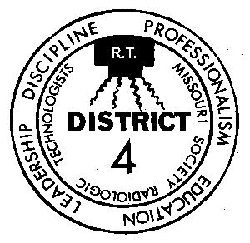

FOURTH DISTRICT
MISSOURI SOCIETY OF RADIOLOGIC TECHNOLOGISTS

Saturday Seminar
April 28, 2018

St Louis Community College – Forest Park
West Café Room (downstairs in the cafeteria)
5600 Oakland Ave • Saint Louis, MO 63110

7:30 – 8:00 Registration

8:00 – 9:00 Journey through Breast Cancer
Norman L. Hente, MS, RT(R), FASRT, FMoSRT

9:00 – 10:00 A Digital World filled with Analog Parts
Jason Young, BS, RT(R)

10:00 – 10:20 Break

10:30 – 11:30 Standardization of Advanced Visualization to Improve CT Workflows
Jessica Chambers, MHA, RT(R)(CT)

11:30 – 12:30 Lifelong Learning or a Life Spent Learning, A look Forward through the Past
Jason Young, BS, RT(R)

Free parking!

Programs are provided free to 4th District members.
Annual membership is $20 per year and expires on June 30.
Fee of $10.00 per credit hour for NON-members.

Registration begins at 7:30am and Program starts promptly at 8:00am.

Approved by the ASRT for 4 Category A continuing education credits.

Program is preliminary and is subject to change.

•••••••••••••••••••••••••••••••••••••••••••••••••••••••••••••••••••••••••••••••••••••

For up-to-date information check our Fourth District Hotline
District HOTLINE (314) 329-5325

